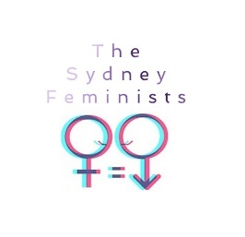
2018 ANNUAL GENERAL MEETING

The Newtown Women’s Library
8 Brown St, Newtown
1st December, 2018

The business of the Annual General Meeting shall be:

- Annual Report Delivered by Tessa Barratt
- Treasurer’s Report Delivered by Vicky Simister
- Social Media Report Delivered by Joseph Salemi on behalf of Neha D’Souza
- Workshop Report Delivered by Brianna Attard
- 2019 Committee Positions Voted upon as follows:
- President – Tessa Barratt
- Treasurer – Vicky Simister
- Secretary – Joseph Salemi
- Ordinary Committee Member – Brianna Attard

The Sydney Feminists will close from 2018 from 7th December and will return on the 7th January

